**PIZZA SALES SQL QUERIES**

***KPI’s***

1. Total Revenue:

SELECT SUM(total_price) AS Total_Revenue FROM pizza_sales;

Output:

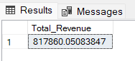

1. Average Order Value

SELECT (SUM(total_price) / COUNT(DISTINCT order_id)) AS Avg_order_Value FROM pizza_sales

Output:

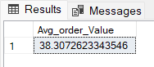

1. Total Pizzas Sold

SELECT SUM(quantity) AS Total_pizza_sold FROM pizza_sales

Output:

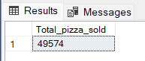

1. Total Orders

SELECT COUNT(DISTINCT order_id) AS Total_Orders FROM pizza_sales

Output:

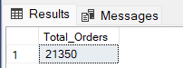

1. Average Pizzas Per Order

SELECT CAST(CAST(SUM(quantity) AS DECIMAL(10,2)) /

CAST(COUNT(DISTINCT order_id) AS DECIMAL(10,2)) AS DECIMAL(10,2))AS Avg_Pizzas_per_order

FROM pizza_sales

Output:

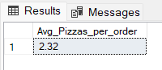

***Daily Trend for Total Orders***SELECT DATENAME(DW, order_date) AS order_day, COUNT(DISTINCT order_id) AS total_orders

FROM pizza_sales

GROUP BY DATENAME(DW, order_date)

Output:

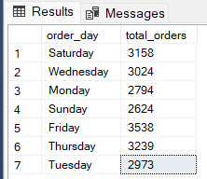

***Monthly Trend for Orders***

SELECT DATENAME(MONTH, order_date) AS Month_Name, COUNT(DISTINCT order_id) AS Total_Orders

FROM pizza_sales

GROUP BY DATENAME(MONTH, order_date)

Output:

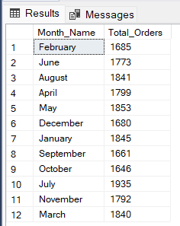

***% of Sales by Pizza Category***

SELECT pizza_category, CAST(SUM(total_price) AS DECIMAL(10,2)) AS total_revenue,

CAST(SUM(total_price) * 100 / (SELECT SUM(total_price) from pizza_sales) AS DECIMAL(10,2)) AS PCT

FROM pizza_sales

GROUP BY pizza_category

Output:

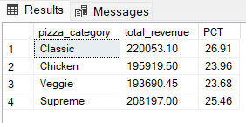

***% of Sales by Pizza Size***

SELECT pizza_size, CAST(SUM(total_price) AS DECIMAL(10,2)) AS total_revenue,

CAST(SUM(total_price) * 100 / (SELECT SUM(total_price) FROM pizza_sales) AS DECIMAL(10,2)) AS PCT

FROM pizza_sales

GROUP BY pizza_size

ORDER BY pizza_size

Output:

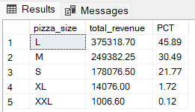

***Total Pizzas Sold by Pizza Category***

SELECT pizza_category, SUM(quantity) AS Total_Quantity_Sold

FROM pizza_sales

WHERE MONTH(order_date) = 2

GROUP BY pizza_category

ORDER BY Total_Quantity_Sold DESC

Output:

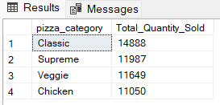

***Top 5 Pizzas by Revenue***

SELECT Top 5 pizza_name, SUM(total_price) AS Total_Revenue

FROM pizza_sales

GROUP BY pizza_name

ORDER BY Total_Revenue DESC

Output:

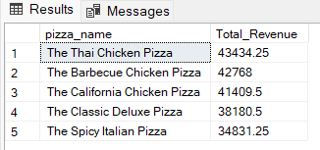

***Bottom 5 Pizzas by Revenue***

SELECT Top 5 pizza_name, SUM(total_price) AS Total_Revenue

FROM pizza_sales

GROUP BY pizza_name

ORDER BY Total_Revenue ASC

Output:

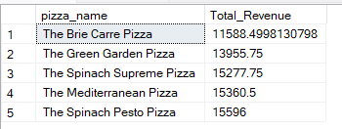

***Top 5 Pizzas by Quantity***

SELECT Top 5 pizza_name, SUM(quantity) AS Total_Pizza_Sold

FROM pizza_sales

GROUP BY pizza_name

ORDER BY Total_Pizza_Sold DESC

Output:

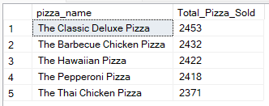

***Bottom 5 Pizzas by Quantity***

SELECT Top 5 pizza_name, SUM(quantity) AS Total_Pizza_Sold

FROM pizza_sales

GROUP BY pizza_name

ORDER BY Total_Pizza_Sold ASC

Output:

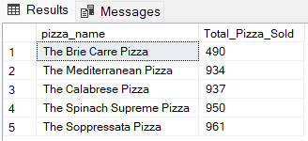

***Top 5 Pizzas by Total Orders***

SELECT Top 5 pizza_name, COUNT(DISTINCT order_id) AS Total_Orders

FROM pizza_sales

GROUP BY pizza_name

ORDER BY Total_Orders DESC

Output:

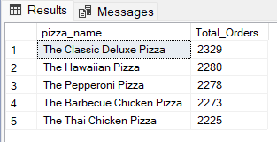

***Borrom 5 Pizzas by Total Orders***

SELECT Top 5 pizza_name, COUNT(DISTINCT order_id) AS Total_Orders

FROM pizza_sales

GROUP BY pizza_name

ORDER BY Total_Orders ASC

Output:

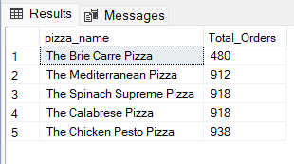

We can apply pizza_category or pizza_size filters on any of the above queries by using **WHERE** clause. Example:

SELECT Top 5 pizza_name, COUNT(DISTINCT order_id) AS Total_Orders

FROM pizza_sales

WHERE pizza_category = 'Classic'

GROUP BY pizza_name

ORDER BY Total_Orders ASC